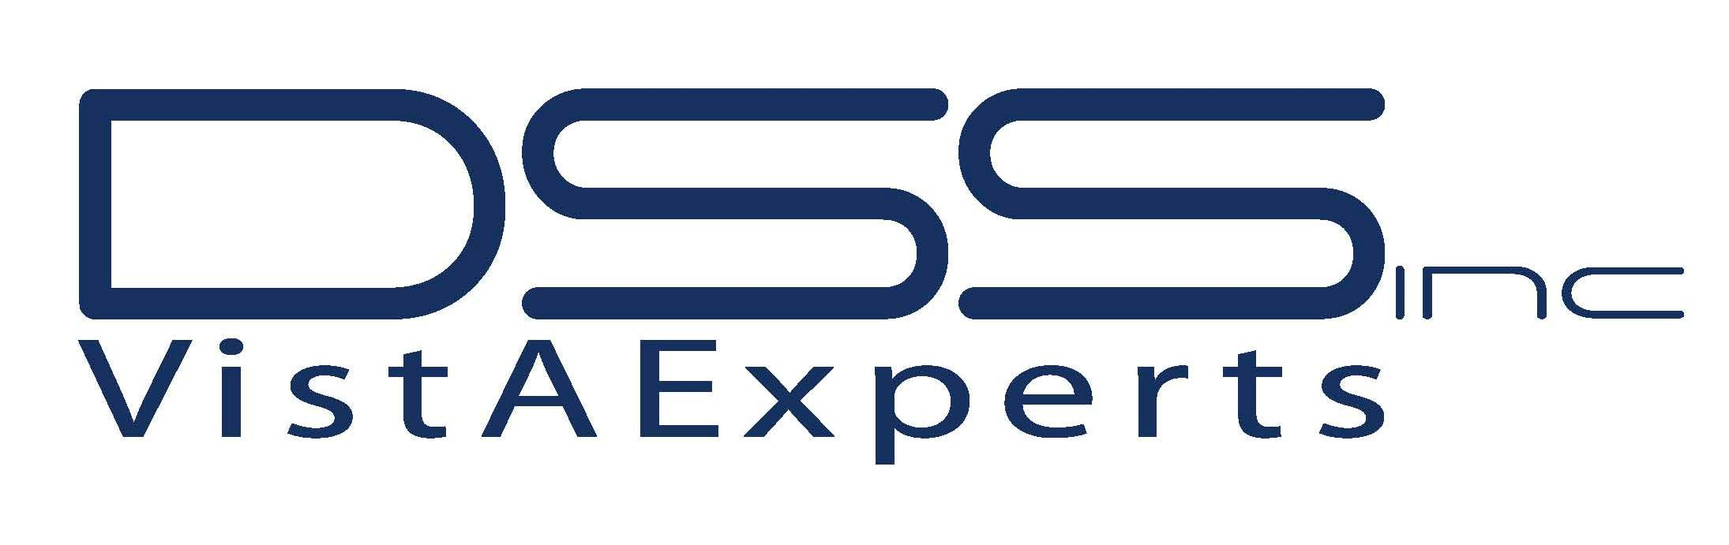

ClintegrityTM VA Chart Complete (VACC)
ENHANCEMENT REQUEST FORM

Ticket #: | Date of request:
VISN: Facility: | Clintegrity version:
Requestor name: | Contact phone #:
Contact email: | Submitted by:
Screenshots added below? Yes No
Describe Enhancement:

Describe what is/is not occurring in current version:

Is a VA change necessitating this enhancement? Yes No If “Yes”, please describe:

Will the enhancement be visual? Yes No If “Yes”, please describe:

Will this enhancement benefit all facilities? Yes No If “Yes”, please describe:

Will any process be affected by this change: Yes No If “Yes”, please describe:

What is the urgency of this enhancement? Low Medium High

Enhancement Committee Use Only
Date Request Received:
Approved Denied Duplicate | Priority: 1: High 2: Medium 3: Low
Comments:

Resolution:

Judgment Date: | Released in Version: Quarter/Year:

Please save the completed form, including your facility name and email it to Christine Durnell at christine.durnell@nuance.com

All enhancements are subject to review. You will be notified when a decision is made on your request. Thank you.

